Genetic analysis of two species of imported caviar

Introduction
There are currently 25 extant species of sturgeon distributed primarily in the northern hemisphere in major waterways and rivers of North America, Europe, and Asia (Pikitch et al., 2005). Representing a distinct lineage, the sturgeon is a representative of the class Actinopterygii (Pikitch et al., 2005). Sturgeons are chiefly diadromous, long-lived (>25 years), and only reproduce in freshwater (Pikitch et al., 2005). All species of sturgeons are considered to be at risk due to their infrequent breeding (no more than every two years) and late maturation (Pikitch et al., 2005). Sturgeons are also at risk from habitat degradation and over-harvesting to supply the international black caviar market (Pikitch et al., 2005). Many of the 25 species of sturgeon are considered close to extinction (Brainard, 1998). Under acute and significant threat are the 3 most sought after species in the Caspian Sea (Beluga, Huso huso; Sevruga, Acipenser stellatus; and Osetra, Acipenser gueldenstaedtii) (Brainard, 1998).
Black caviar is the unfertilized eggs of sturgeon and is a highly regarded delicacy in North America, Europe, Japan, and Switzerland (Pikitch et al., 2005). Black caviar is produced primarily in the Caspian Sea region by Iran, Kazakhstan and Russia (Pikitch et al., 2005). Starting in the late 1980’s, sturgeon catches in the Caspian Sea have declined dramatically due to over-harvesting and habitat degradation (Pikitch et al., 2005). Catches of sturgeon have declined from a peak of 30,000 tons in 1985 to a record low of 5,000 tons by 1995 (Pikitch et al., 2005). During the same time period, international demand for black caviar has increased, driving prices up to $5000/kg for beluga caviar (Pikitch et al., 2005). The current high price of black caviar coupled with the dissolution of the Soviet Union has stimulated a thriving trade in mislabeled, poached or otherwise illegal caviar (Pikitch et al., 2005).
Using specifically designed primers and PCR techniques, Birstein et al. (1998) has estimated that 23% of caviar sold in New York shops was mislabeled. This situation presents a dilemma for the protection of sturgeon worldwide. It is feared that as stocks of the highest grade of caviar producing sturgeon fall, unscrupulous dealers will dishonestly substitute lower grades or possibly resort to selling poached caviar (Birstein et al., 1998). The selling of poached or mislabeled caviar may place additional species of sturgeon at risk to supply the international caviar market.
The development of specific primers by Birstein et al. (1998) for the three most common types of caviar (Beluga, Huso huso; Sevruga, Acipenser stellatus; and Osetra, Acipenser gueldenstaedtii) represents a possible method to aid in the enforcement of conservation laws and regulate the importation of caviar. Following Birstein’s method, specific mDNA sequences within the cytochrome b gene are amplified using PCR (Birstein et al., 1998). The bands are then visualized using gel electrophoresis and an agarose gel (Birstein et al., 1998). Using the techniques outlined by Birstein et al., (1998) this study aims to determine the true identity of two kinds of caviar sold as Sevruga and Osetra.
Methods
Sevruga and Osetra caviar was obtained from an internet vendor that specializes in imported caviar and our control caviar was purchased at a chain grocery store. Individual eggs from each type of caviar (Sevruga, Osetra, and control) were placed into a 1.5mL eppendorf tube. DNA extraction and purification was done using a Qiagen blood and tissue kit with Qiagen spin-columns. One-hundred and eighty microliters of buffer AL was added to each of the samples. The eggs were lysed using a pipette tip and 20μL of Proteinase K was added to denature cellular proteins. The mixture was incubated at 56 C until the sample appeared homogenous.
To the cell homogenate of each sample, 200μL of 0 C Ethanol was added and the mixture was applied to spin-columns. The spin-columns were centrifuged at 8000 rpm for 1 minute. The tubes containing the supernatant were discarded and 500μL of buffer AW1 was added. The tubes were again centrifuged at 8000 rpm for 1 minute. The supernatant was discarded and 500μL of buffer AW2 was applied to the spin columns. The spin-columns were centrifuged at 20,000 rpm for 3 minutes.
The spin-columns containing the DNA were removed and placed into a 1.5mL eppendorf tube. Twenty microliters of buffer AE were added to each spin column and the column was centrifuged for 1 minute at 8,000 rpm.
The entire class’s samples were divided into 2 main PCR reactions, PCR #1 and PCR #2. PCR #1 contained the necessary primers to initiate a PCR reaction on any sturgeon DNA. PCR #2 contained the necessary primers to initiate a PCR reaction for Sevruga sturgeon only. For each reaction, 2μL of the purified DNA was mixed with 22 μL of the primer-containing PCR mixture.
Three microliters of loading dye was added to each of the finished PCR reactions. Ten microliters of the dyed samples were loaded in a 10% agarose gel as indicated by table 1. The gel was run at 80V for 1 hour and then 100V for .5 hours. The gels were then stained with SYBR gold stain to visualize the bands.
Table 1: Loading of samples on the 4 gels. (O= Osetra, S= Sevruga, C= control)

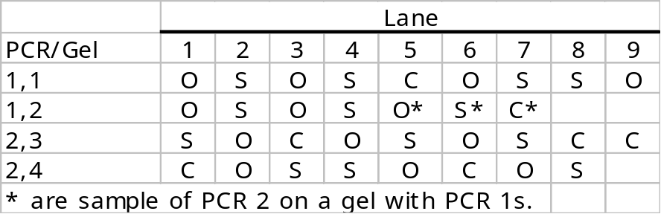

Results
The results indicate that all of the caviar samples that were sold as either Sevruga or Osetra caviar did originate from a sturgeon. Amplification of the sturgeon specific cytochrome b gene was evidenced by the presence of bands in lanes 1,2,4,6,7, 8 and 9 of gel # 1;PCR 1 (figure 1). Lanes 1-4 of gel #2; PCR 1 also show bands due to the amplification of the proper sturgeon-specific sequence (figure 1). Lane 3 of gel #1; PCR 1 shows no band indicating possible PCR failure (figure 1).
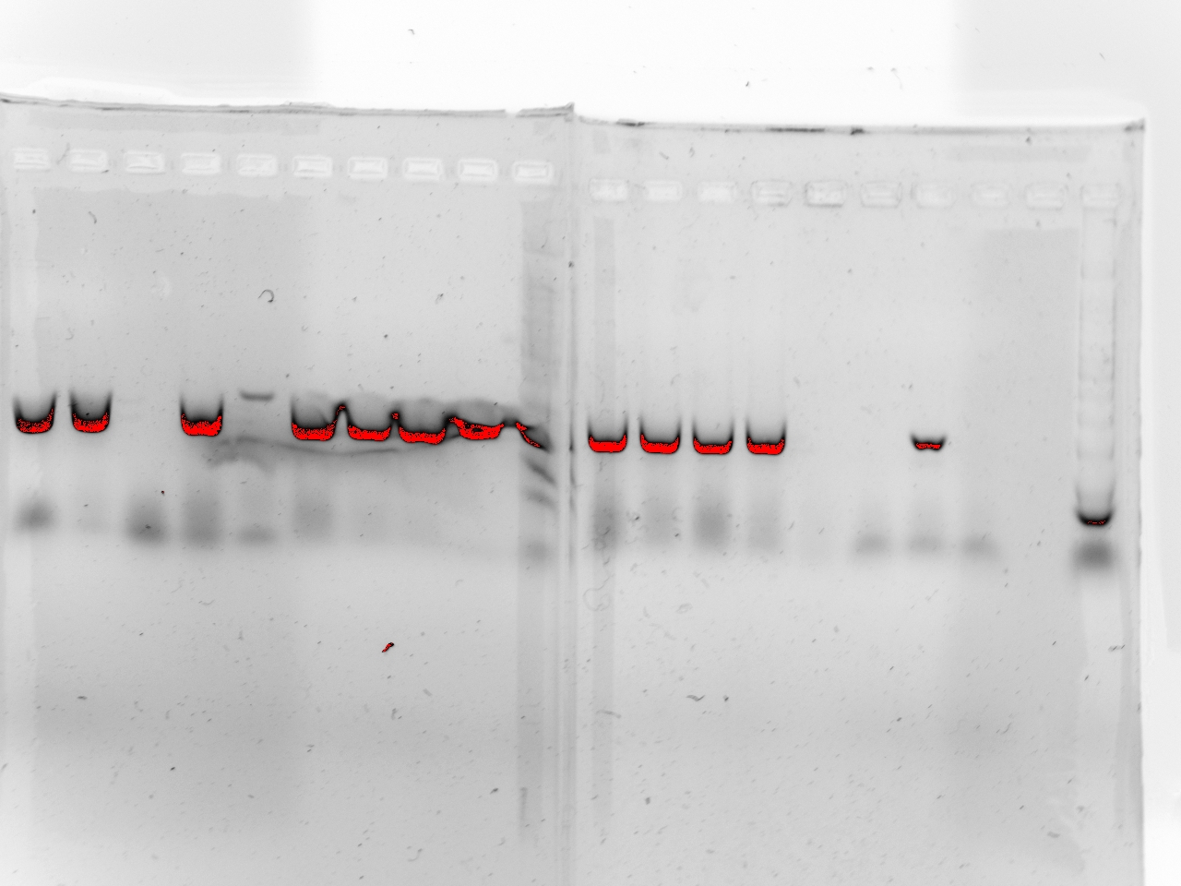
1 2 3 4 5 6 7 8 9
o s o s c o s s o

1 2 3 4 5 6 7
o s o s o s c

Gel #1 PCR 1
Gel #2 PCR 1
Figure 1: Photograph of gels from PCR #1 (Sturgeon-specific primers)
O=Osetra sample, S=Sevruga sample and C =Control.
(Note: lanes 5, 6 and 7 of Gel #2 are PCR#2).

The Sevruga-specific PCR indicates that our samples were, in fact, Sevruga caviar. Lanes 1, 5 and 7 of Gel #1; PCR 2 show bands at the 150 bp region indicating that our PCR was successful (figure 2). Lanes 3, 4 and 8 of Gel 2; PCR 2 also show the proper bands (figure 2). There were possible failed PCR reactions as indicated by lane 6 of gel #1 (figure 1). As expected, the control samples generally did not amplify. However, lane 7 of gel #2 did show amplification for Sevruga sturgeon (figure 1). Lanes 1 and 6 of gel #2; PCR 2 also show bands at the 150bp region (figure 2).

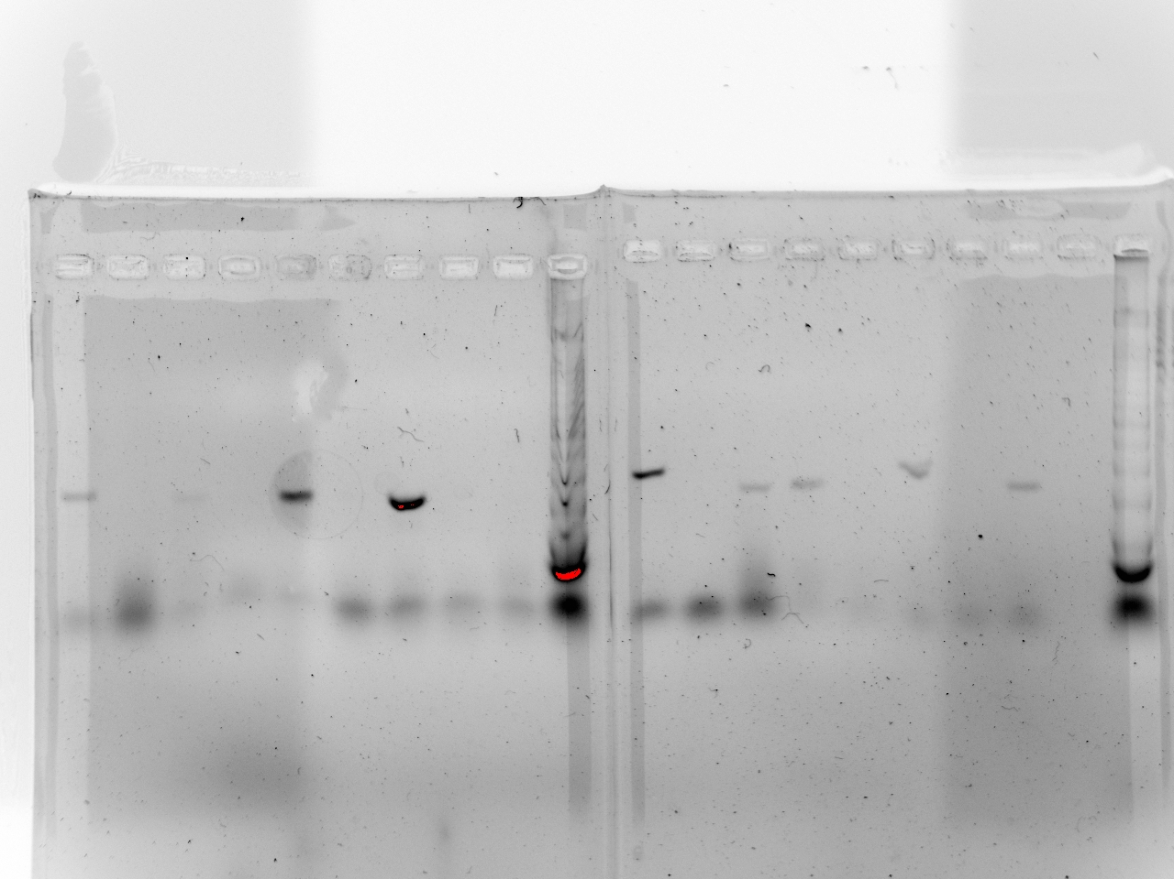
1 2 3 4 5 6 7 8 9
s o c o s o s c c
1 2 3 4 5 6 7 8
c o s s o c o s
Gel #1 PCR 2
Gel #2 PCR 2
Figure 2: Photograph of gels from PCR 2 (Sevruga-specific primers) (O=Osetra, ___S=Sevruga and C=control).

Discussion
Despite some failed PCR reactions (figures 1 and 2) most samples did amplify. The results of the PCR reaction indicate that all of the samples were sold with proper labeling (barring samples with failed PCR). These results contrast with the results obtained by Birstein et al. (1998) who found that 23% of sampled caviar was mislabeled.
It is likely that the existence of a technique for verifying the identity of imported caviar may have discouraged importers and poachers from attempting to sell illegal caviar. This technique was first reported in 1998 and has had nearly a decade to dissuade illegal caviar poaching and sales (Birstein et al., 1998). Initial conclusions from this study indicate that the ability to identify caviar via DNA analysis has had a deterrent effect. Of course, more sampling from other vendors over a period of time would bolster these conclusions.
Somewhat unexplainable is the amplification of the Sevruga-specific sequence for the generic grocery store caviar. It seems highly unlikely that caviar purchased at a grocery store would contain extremely expensive Sevruga sturgeon roe. While it is possible that the grocery store caviar contained Sevruga sturgeon, there are other possibilities that must be explored.
The control samples did show amplification for the sturgeon-specific PCR (figure 1). Some of the control samples also show amplification for Sevruga-specific PCR. It is possible that contamination, via unchanged micropipette tips could have created these results. The fact that some control samples did not show amplification seems to support this analysis (figures 1 and 2). However, none of the Osetra caviar showed bands for the Sevruga specific reaction (figure 2). If contamination were an issue it is unlikely that only the controls would be contaminated.
It is unknown exactly how the caviar is processed but it is possible that cheaper, grocery store brand caviar is processed in the same facility with more expensive grades of caviar. The processing of several types of caviar in the same facility could yield false positive results during a PCR reaction due to DNA contamination. It is also possible that the grocery store brand contained a variety of egg types including Sevruga sturgeon. The cheaper grocery store brand may be a mix of several types of caviar packaged by color and size but not species.
DNA contamination at the processing facility or a mixing of roe from several species seems the most likely explanation due to the amplification of the control sample for both the sturgeon-specific PCR and the Sevruga-specific PCR.

Work Cited

Birstein, V.J., Doukakis, P., Sorkin, B. and R. Desalle. 1998. Population aggregation analysis of three caviar-producing species of sturgeons and implications for the species identification of black caviar. Conservation Biology. 12(4):766-775.

Brainard, J. 1998. DNA fingerprinting to track caviar. Science News. 154 (8):116.
Pikitch, E.K., Doukakis, P., Laucks, L., Chakrabarty, P., and D.L. Erickson. 2006. Status, trends and management of sturgeon and paddlefish fisheries. Fish and Fisheries. 6: 233-265.

